**3. Related work**

General Linked Data based works

Recommendation by Prof. Harth

**4. Demo: WoT Application on top of SoLiD**

**4.1 The Concept**

The following diagram best describes our concept of integrating **Things** inside the SoLiD ecosystem to make them accessible, controllable and sharable from the web through a semantic interface.

**Host-Device**

The Host-Device refers to the computing unit which hosts an instance of a SoLiD server. It brings all the smart thing under the SoLiD ecosystem through a **controller-module**. The POD facilitates necessary files to discover the things (device.ttl), to control them (device-control.ttl), or share the data (device-data.ttl). Rasberry Pi, Ardino etc. be example of such device.

**User-Agent**

The user-agent can be thought of as an application and can operated by a user or by an intelligent machine. The application will be capable of exchanging semantic queries.

**Solid Server**

Solid server is the glue between the host-device and the user-agent

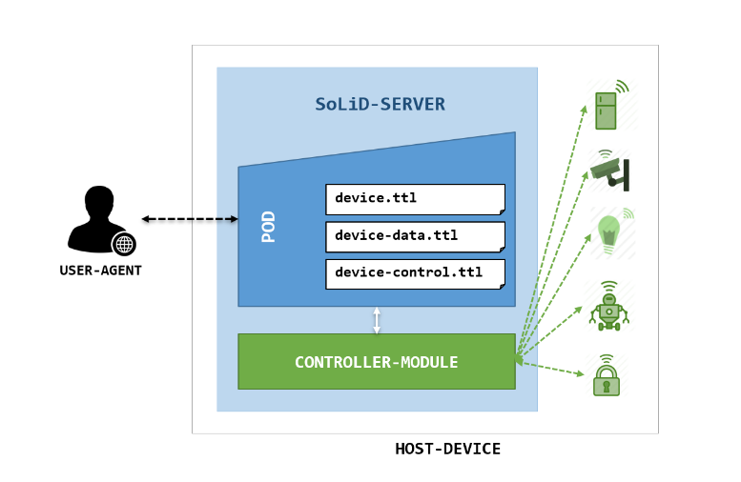

**4.2 The Proof of Concept**

**4.2.1 Used technologis:**

**Websocket**

**Rdflib**

**4.2.2 Described Things**

|  |
| --- |
| device.ttl |
| @prefix : <#>.  @prefix td: <https://www.w3.org/2019/wot/td#>.  @prefix ex: <https://example.org/vocab#>.  : td:thing <#1>.  : td:thing <#2>.  <#1> ex:status "on".  <#2> ex:status "off". |
|  |
| device-control.ttl |
| @prefix : <#>.  @prefix td: <https://www.w3.org/2019/wot/td#>.  <>  td:thing  “””{“id”:1, “status”:”on”}”””, “””{“id”:2, “status”:”on”}”””. |
|  |
| device-data.ttl |
| @prefix : <#>.  @prefix td: <https://www.w3.org/2019/wot/td#>.  <>  td:thing  “””{“id”:1, “status”:”on”}”””, “””{“id”:2, “status”:”on”}”””. |

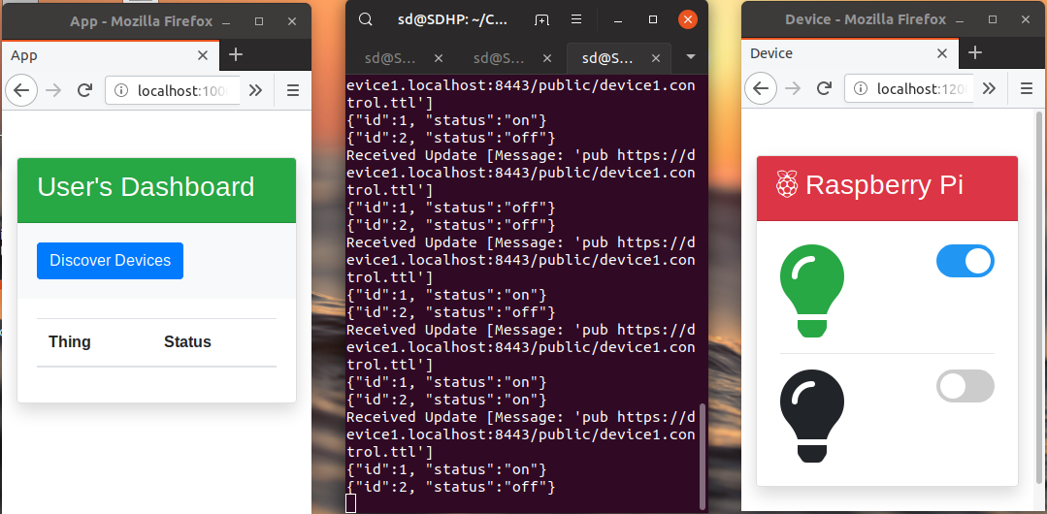

|  |  |  |
| --- | --- | --- |
|  |  |  |
| **Figure-1** | **Figure-2** | **Figure-3** |

**4.2.3 How it works**

**4.3 Challenges**

**5. Conclusion**